**Application Form - Stock Updation on Direct Supply / Rejected Item - Block**

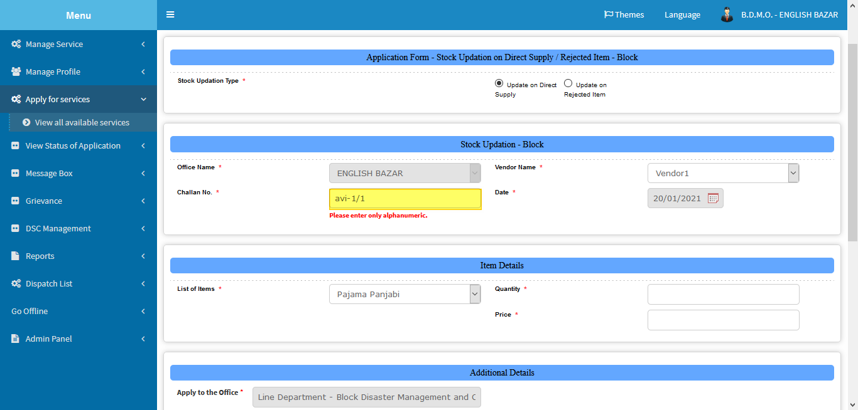

Challan no. should not be alpha numeric.

Use special character js.

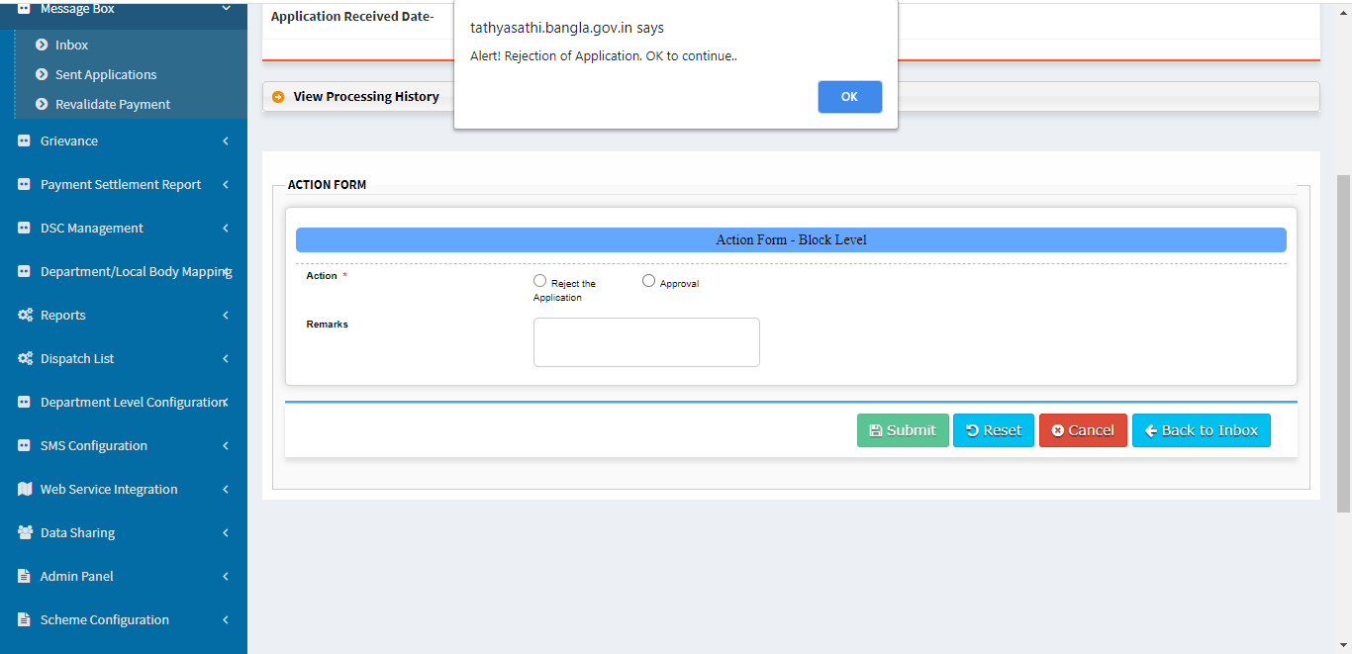

If possible uniform the position of radio button.

No need of showing alert on selecting reject radio button

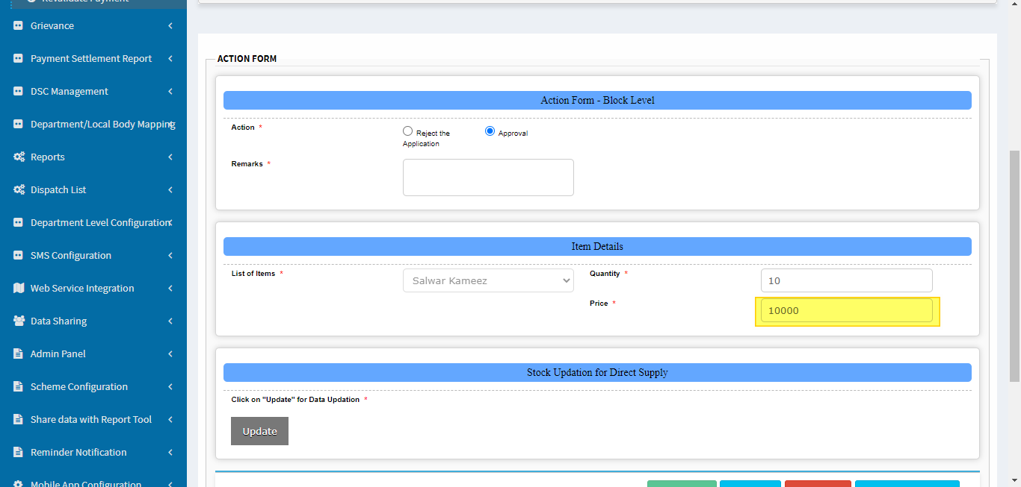

No need of showing price

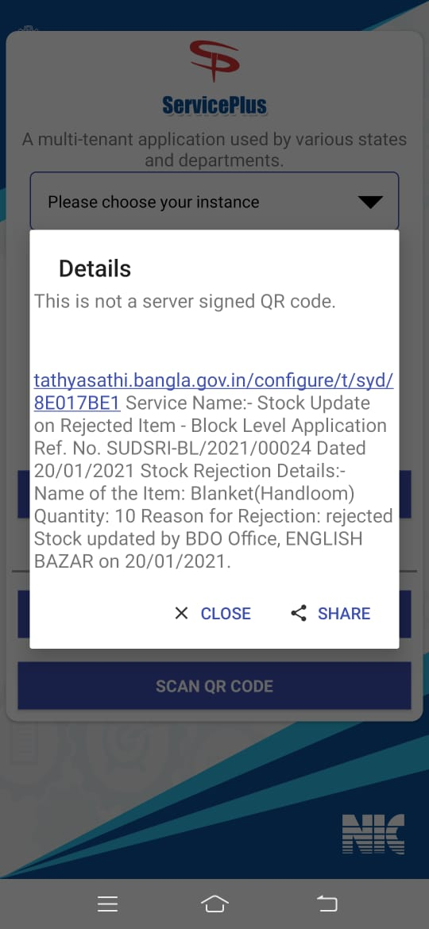

Separate each data with comma(,).